INFORMATION FOR SCANNED PHOTO IMAGES FROM OUR FAMILY’S NEGATIVES

Dear Helen, Charley, Lisa, David and Christopher -

This is the current status of our Family’s Collection of photos. Disorganized may be an understatement.

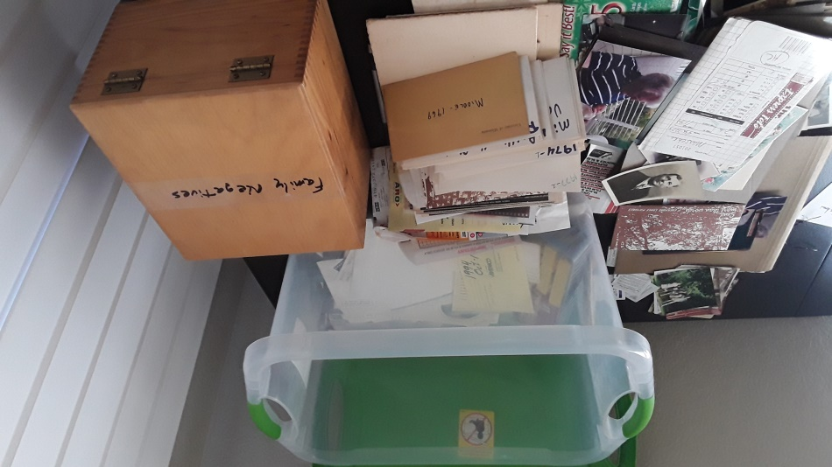

I am considering digitalizing our Family’s Collection of Photos to preserve them as an organized part of our Family History. In order to most effectively do this I would scan each negative, slide and photo to convert all of the photos to a digital collection. However, I am not certain if this will be worth the effort from all of us. After the scanning is complete, each of us will need to annotate the photos with information about Who? What? Where? and When? Then this information will need to be compiled into either (1) Captions for many of the Images or (2) into a catalogue with descriptions of many of the photos. We would be doing this not only for ourselves but for your children and our descendants. So, I need you to tell me if this could provide benefits commensurate with the work involved.

ALERT!! – We are probably “looking at” a collection of 20,000 to 30,000 Photos. So, this will be a major undertaking (over time of course) so I need Y’All to provide guidance to me if we should proceed. If so, do you have a recommendation of the best way to accomplish this chronicling of our Family’s History that is resident in this large set of Family Photos?

In order to provide you an introduction to this project, I send to each of you a MicroSD Card with 1,015 scans of negatives. The folder is titled “SCANS OF PHOTO NEGATIVES 1”. Please view them and provide me your responses about Who? What? Where? and When? for those images about which you have recollections.

Please state specific information if you have it (e.g. – that photo of your birthday was for what year?) or make guesses (e.g. – perhaps, maybe, possibly, etc.) about information/guidance regarding the photo. Please identify the scan by number or by collective numbers if you are referencing a sequence of photos.

As examples of the type of information that would be nice to have – (1) do you know any of the people in 350 and what the event was? (2) What do you remember about our family-outing in 454? (3) Who are the people and what is the event in 464 and 465? With these examples I think you “get the picture”.

In order to assist you, I provide you an “overview document” about my recollections regarding this first collection of images and that overview document is next in this letter. You will find a copy of this overview document on the MicroSD Card.

AND PLEASE return the MicroSD cards to me. All of you in Kalamazoo can send them in the same envelope.

And by the way, be certain to look at Images 441 and 442!!
HERE IS THE OVERVIEW DOCUMENT

1-93
Mom’s and Dad’s vacation to Hawaii
94-108
Hot Air Balloon
Aerial Photos – Kalamazoo Airport, Loy Norrix (?) and around Kalamazoo
109-135
Mom’s and Dad’s trip to Western USA
136-159
Mom’s and Dad’s trip to Western USA
160-178
Mom’s and Dad’s trip to Western USA
179-198
Pre-Christmas 3121 Fleetwood
Family – 7 members and Cindy
199-224
Mom and Dad visits Helen’s relatives in Lemmon, SD
225-258
Mom and Kids at Alcatraz
Philmont – Charley, David and Dad
259-272
Halloween
Kids – Bus stop?
Christmas 3121 Fleetwood with Grandma Odell
273-288
All at 3121 Fleetwood
Dad’s Birthday
Angie’s Birthday
Chris’s Birthday
Lisa’s Birthday
Mackinac Bridge
289-318
Chris’s and Lisa’s Soccer
School Auditorium Gathering – Chris
Charley Soccer
Camping – Family and Grandma
319-344
Christmas 3121 Fleetwood – with Josts
Josts at Airport
Boy Scouts – Dave?
Dad’s Birthday – 3121 Fleetwood
Chris’s Birthday – 3121 Fleetwood
Birthday Dining-Out – Lisa
345-356
Josts and our family – 3121 Fleetwood
Chris Buesing
People I don’t know
357-376
Dad’s Birthday
David’s Birthday
Charley’s Birthday with Josts
Lakeside Scenery – Where? When?
377-398
Charley, Lisa, Chris, Angie and David to school – 3121 Fleetwood
Charley’s Birthday – Darlene at Table – 3121 Fleetwood
Angies Birthday with Grandma Odell, David and Helen
Charley Boy Scouts
Our kids and Grandma Odell
399-405
Kids and Mom at a park (Como Park? In St. Paul)
One negative strip of slides is missing
408-423
Kids, Helen and Grandma Odell at 202 Boston
Grandma Marschke and kids – 202 Boston
Angie – 202 Boston
Kids Easter at 202 Boston
Chris in Dad’s Master Arts Graduation “shawl” – taken at Rod’s house
424-447
Halloween Camping with Page-Woods
Charley church confirmation
Chris’s Baptism with Josts in the photo
Charley in church with Grandma Odell
Airport with Grandma Odell
Lisa Choir – Crossroads Mall, Portage
Chris and Dominos
Family dining-out
Lisa and a friend
448-483
Dave’s Birthday
Michigan Sand Dunes
Camping – family and Grandma Odell
David beaming proud
Lisa – Piano recital
Angie
Gathering in Rainy Parking Lot – most people I don’t know
Tony Marfia swim school – Lisa and Angie
Charley Birthday – 3121 Fleetwood
Softball game between Kalamazoo City Commission and Portage City Council
?Helen’s Birthday?
484-491
Gilmore Auto Museum – brother Jon, Grandma Odell, Angie, Charley, Chris
Brother Jon and our family – 3121 Fleetwood
Lou Ann Marschke (Rod’s wife), Joyce and our kids on Couch – where?
492-506
California Bike Trip – Dad, Rod (with Scott and Jon) and Jerry (with Jerry Jr., Steve and Craig)
Grandma Odell and kids – 3121 Fleetwood
507-519
Lincoln Cabin – family and Grandma Odell
Dad’s Master of Arts Degree – Family and Grandma Odell
520-541
Christmas – family and Grandma Odell – 3121 Fleetwood
Family exiting ?Burger King?
Grandma Odell at Airport
Chris’s Portage Bantam Basketball
542-554
Christmas – 3121 Fleetwood
3121 Fleetwood – was this the Christmas with temps round 70 deg. And then snow
Family in summer clothes at Nature Preserve near Kalamazoo Community College
Charley Refereeing Soccer
555-558
Married Student Housing – 1180 Gibbs
David and Lisa as infants on a blanket outdoors with bottles
559
Family photo with Nadja – 3121 Fleetwood
560-566
3121 Fleetwood with new roof – was the repair done for the sale of this house in 1993?
Nissan Truck – Charley’s
567-594
David and Tracie wedding
Charley, Lee and David - ?take at Adler’s house? – slide 594
595-610
Chris’s soccer
Angie’s soccer
Mom and Dad on sidelines
Chris, Angie and Dave receive medals
611-630
Halloween – 3121 Fleetwood
Family meal with Josts – 3121 fleetwood
Kids swimming in an indoor pool
Angie Birthday
Dad with Gorilla statue – Birthday – 3121 Fleetwood
Chris with Curious George stuffed toy – Birthday?
631-645
Charley watching TV
Dad’s Master of Arts Degree – Rod’s house – Dad, Lisa, David and Charley
Charley, Lisa and David dressed-up on the back step of Grandma Odell’s house
Lisa’s Birthday
David, Charley, Lisa on couch and with an infant (who is the infant?
646-667
Christmas – 3121 Fleetwood (Helen labelled these as “Xmas 1984”)
668
Dad’s Ph.D. celebratory cake
669-692
Mom’s Chart St. house in Plainwell – dogs, cat, kids, Tracie, Caleb, Dave’s and Tracie’s dog
(name?), Dave on couch with Caleb, Tracie on couch with their dog
693-698
Jerry, Joyce, brother Jon and Jerry Jr. – wedding of Jill Marschke and Paul Huot
(negatives dated 5 7’94)
699-710
Dad, Dave, Chris and Angie at camp Greenwood
Canoeing
Springfield, IL, Lincoln Monument
Dave Hatfield
David Way
711-730
Cub Scout Camping Trip
731-747
Jill Marschke and Paul Huot Wedding
Scott and wife Jill dated 5 7’94
On same strip are Lou (Rod’s wife) with Kaye and Jerry Brezina plus photo of David and two
Dogs (dated 5 10’94)
On same strip are nephew Jon with a baby and a photo of brother Jon, Jerry and Rod
(dated 5 7’94)
On the same strip are a photo of Jerry Jr., Joyce and Jerry; a photo of brother Jon with a lady
(whom I don’t recognize) and a photo of brother Jon, Jerry and Rod (dated 5 7’94)
748-767
Disney – photo of Lisa, photo of Dave beside old Yellow taxicab, photo of water fountain at
night (the first two negatives are dated 7 9’93 and the fountain is dated 7 11’93)
Mom’s Plainwell house (dated 8 15’93)
Plainwell Gazebo – photos of Lisa and Angie, photo of David and Tracie, photo of David
Tracie and Dad, photo of David, Lisa, Tracie and Angie (all photos dated 8 22’93)
768-776
Helen’s Plainwell house with snow
Airport – David, Tracie, Carol Schneider, Lee, Mom and Lisa – was this Lisa’s departure
for either the US Marines or the US Navy?
777-791
Charley pre-school
Infant Angie on couch
792-811
Halloween 202 Boston
Charley Birthday – family and Josts
John Jost and our kids
Garage painting – 202 Boston – Charley, David and Lisa
Our kids, Grandma Odell and Dad collecting pumpkins (?our garden 202 Boston?)
Lisa – was this Campfire or Brownies?
Our kids with Halloween costumes
812-831
Angie’s birthday with Jessica E. Woodhouse; also photos with Darlene Jost and the
Pieratt girls – 202 Boston
Grandma Odell on couch
Christmas – 202 Boston
832-851
Cincinnati Zoo – our family with Grandma Odell
852
12044 Oakland Dr., Schoolcraft, MI
853-874
David and Lisa in bathtub with kids I don’t recognize – 202 Boston
Our family (Mom, Charley, David and Lisa) with Grandma Odell – 202 Boston
Our kids sitting on bleachers
David with tortoise at Cincinnati Zoo
4 kids – Charley, David, Lisa and Chris – in single bed – 202 Boston
Kids playing in snow – 202 Boston
Lisa - ?birthday? – 202 Boston
Lisa in bathtub – 202 Boston
Halloween with Angie – 202 Boston
Charley off to school with neighborhood girls
875-876
Helen with ?
Helen Graduation - ?High School?
877-884
Horses (?South Dakota?)
Farmer in his field (?with his son?)
Thaddeus M. Odell and woman with boy
Dam and reservoir
Thaddeus M. Odell with a woman and a man and a boy by Dam
885-896
Helen’s Family
Helen’s schoolmates and teachers
Christmas tree
897-902
Family camping with Grandma Odell
903-930
Grandma Odell’s birthday – 3121 Fleetwood
Grandma Odell camping
Family camping
Grandma Odell sleeping-in
Cindy camping
Chuck and Helen on a Lake Beach
Sun-beams through the woods
Kids at Lake Michigan
Charley’s birthday
931-938
Charley playing goalie for High School Soccer Team
Soccer Trophy – Charley, Mom, soccer team and Tim Heywood
Birthday celebration – ?was this for Charley or David?
939-946
Lisa and Tony High School Prom
947-970
Charley at Portage Northern HS Swim Meet
971-992
John and Jean Wiler’s house – dining with Wilers
Charley Eagle Scout
993-1015
Charley Summer Camp

